Bandit level2 to level3
for login to bandit level 2 use the username id as
Then use ls command to list all the files.
Use cat command to display the contents from the file.
Along with cat command use ./ which is used to the display the contents of the current directory.
So the command which I have used is cat “./filename”.
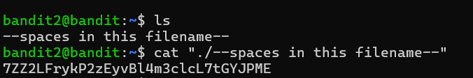
After completing all these commands you will get the password for the next level username id.

